Module 4 : Organizing and Simplifying Data

1. Hierarchy: Create a Hierarchy to Drill Down through the Location data present in Superstore on the view. (Hint: Country -> Region -> State -> City -> Postal Code)

Output:

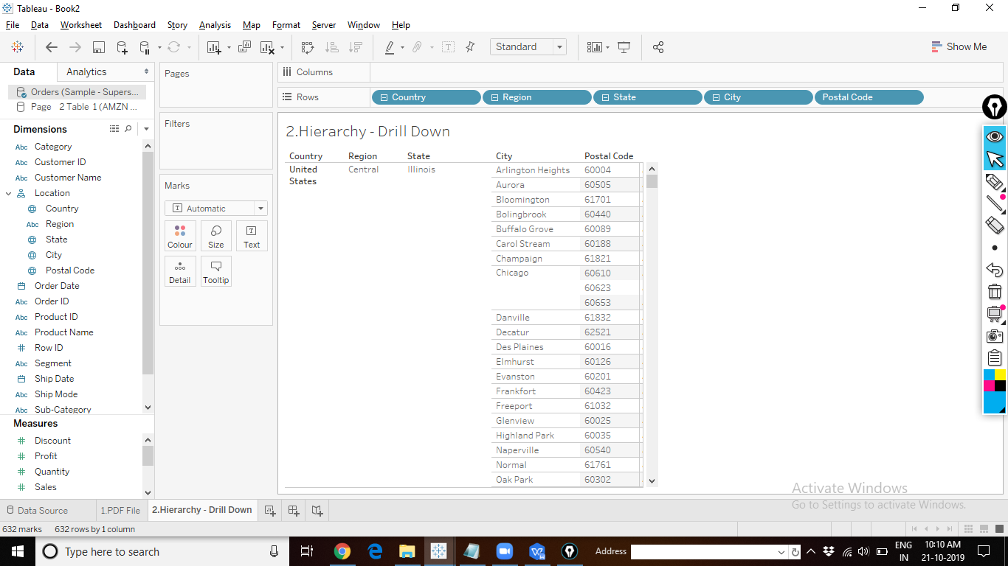

1. Highlighter: Create a Line Chart showing the trends of Monthly Sales and Profits of Superstore, across different Categories. Use Highlighter feature to make the chart readable.

Output:

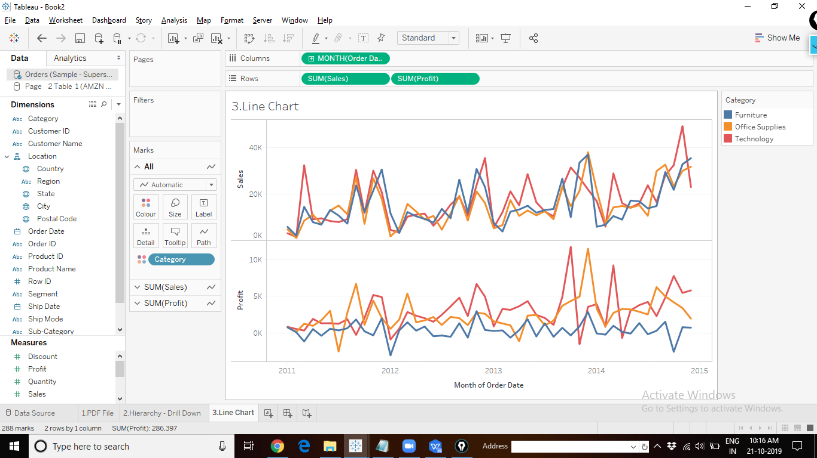

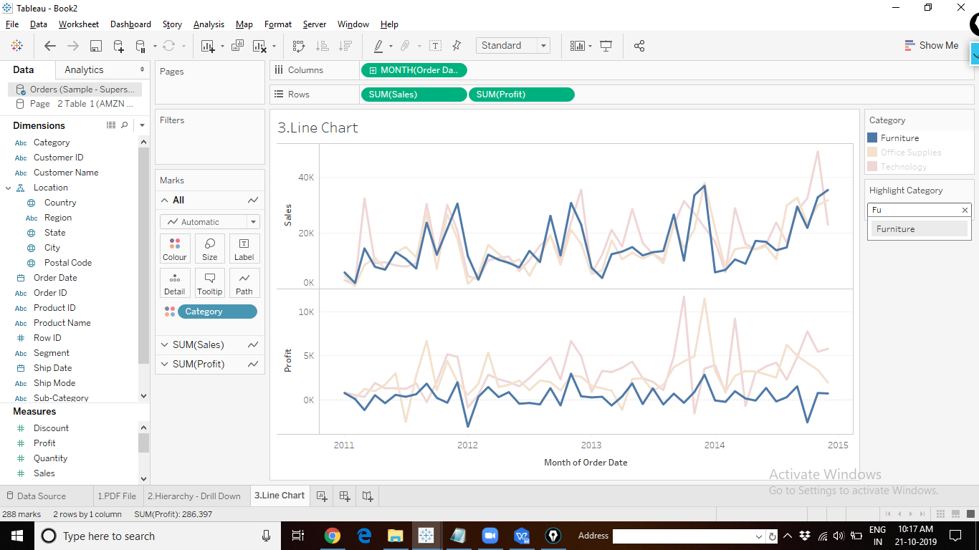

1. Filters: Create a top five conditional filter that will update the top five Customers by Sales based on the region selected in the “Region” filter

Output:

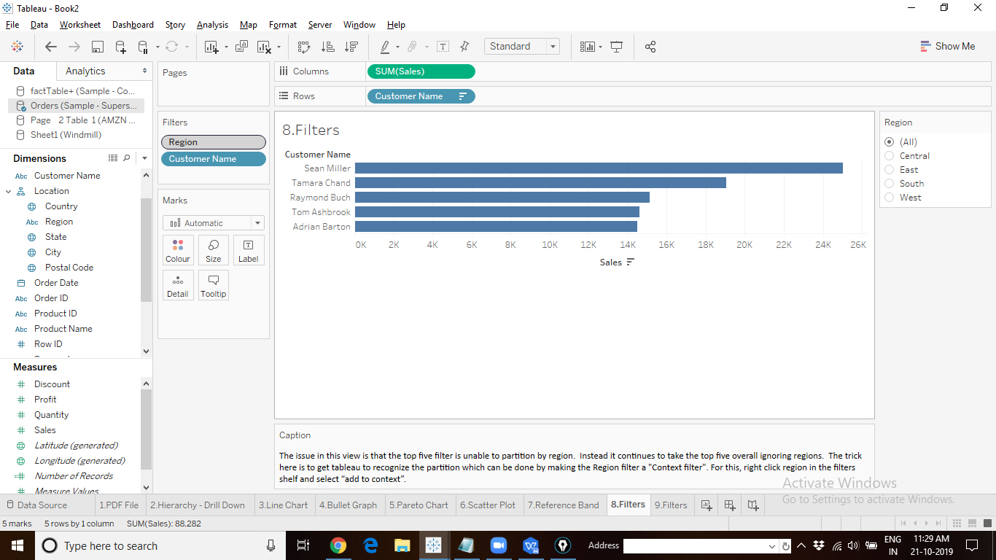

1. Filters: Create a text table displaying the list of Top 3 cities by profit in each state.

Hint:Rank the cities by their profit. Bring “Profit” to the Rows Shelf, and apply Quick Table Calculation “Rank”, this should be “Compute Using -> City”. Change the Sum{Profit) pill to discrete. You will be able to see the cities ranked by profit.

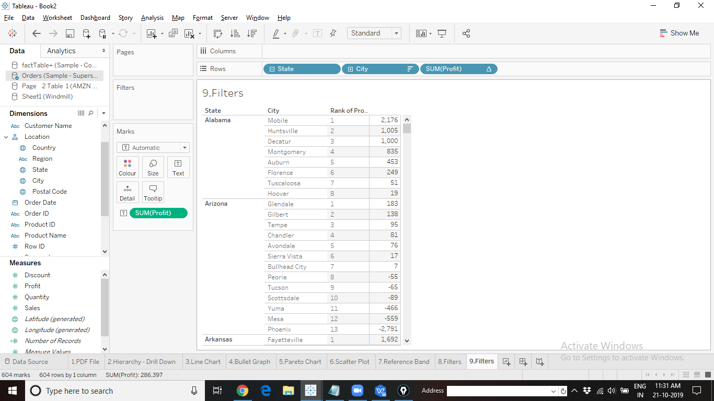

Then take the Sum(profit) pill with Rank QTC applied to it, to the filters shelf, and choose rank 1,2,3.

Output:

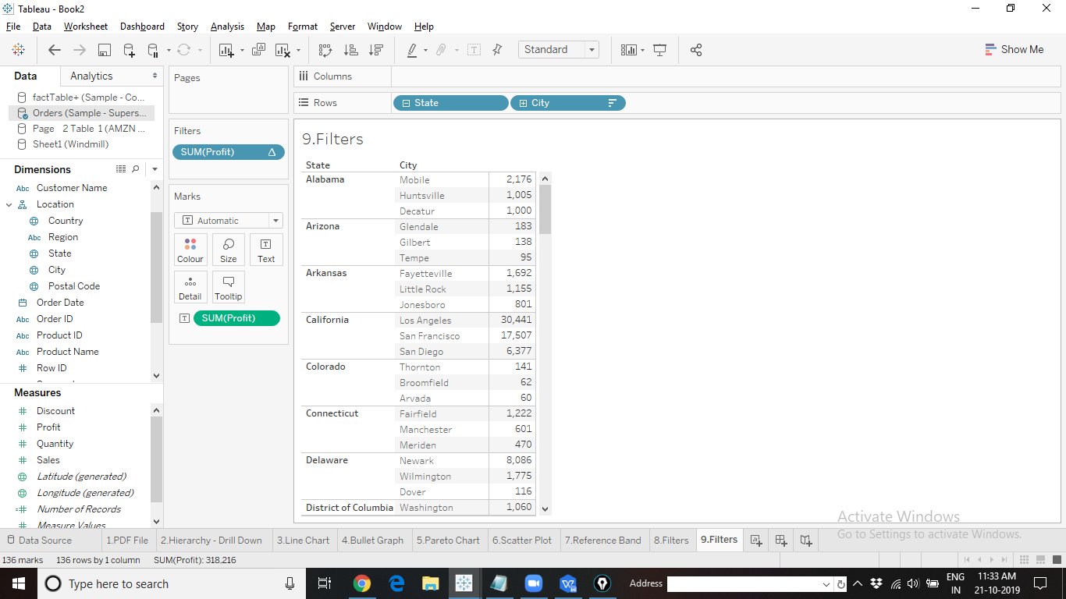

1. Sets: How many customers of the Top 100 list by Profits are also present in Top 100 list by Sales?

Output:

